PHOTOGRAPHER PORTFOLIO WEBSITE

Full Stack Web Application Documentation
Developed By
Harini BR
Technology Stack: HTML, CSS, JavaScript, Spring Boot, MySQL
Version: 1.0

TABLE OF CONTENTS
- Project Overview
- Problem Statement
- Objectives
- Features
- Technology Stack
- System Architecture
- Database Design
- Application Workflow
- API Endpoints
- Screenshots
- Challenges Faced
- Future Enhancements
- Conclusion
1. PROJECT OVERVIEW
The Photographer Portfolio Website is a full-stack web application designed to simplify photography booking management. The application enables customers to explore the photographer's portfolio, register, log in, and book photography sessions through an intuitive web interface.
The system also includes an administrator dashboard that allows the photographer to manage customer bookings efficiently by confirming or rejecting requests. Once a booking status is updated, an automatic email notification is sent to the customer.
The project focuses on providing a modern, responsive, and user-friendly booking experience while demonstrating full-stack web development using Spring Boot and MySQL

2. PROBLEM STATEMENT
Many freelance photographers still rely on phone calls, WhatsApp messages, or social media platforms to receive bookings. Managing these requests manually often leads to scheduling conflicts, delayed responses, and difficulty maintaining customer records.
Customers also have no convenient way to check the status of their booking requests.
This project addresses these issues by providing a centralized web application where bookings can be managed efficiently and customers receive timely updates.

3. OBJECTIVES
The primary objectives of this project are:
- Develop a responsive photographer portfolio website.
- Provide secure user registration and login.
- Enable customers to book photography sessions online.
- Maintain booking information in a MySQL database.
- Provide an administrator dashboard for booking management.
- Send automated email notifications for booking confirmation or rejection.
- Deliver a clean and user-friendly interface.

4. FEATURES

Customer Features
- View photographer portfolio
- Register a new account
- Login securely
- Book photography sessions
- View booking history
- Receive booking status emails
- Responsive interface for desktop and mobile devices

Administrator Features
- Secure administrator login
- View all bookings
- Confirm bookings
- Reject bookings
- Automatic email notification to customers
- Booking status management

5. TECHNOLOGY STACK

Layer | Technology
Frontend | HTML5
Styling | CSS3
Client-side Scripting | JavaScript
Backend | Spring Boot
ORM | Spring Data JPA
Database | MySQL
Email Service | Spring Mail
IDE | Eclipse
API Testing | Postman
Version Control | Git
Repository | GitHub

6. SYSTEM ARCHITECTURE
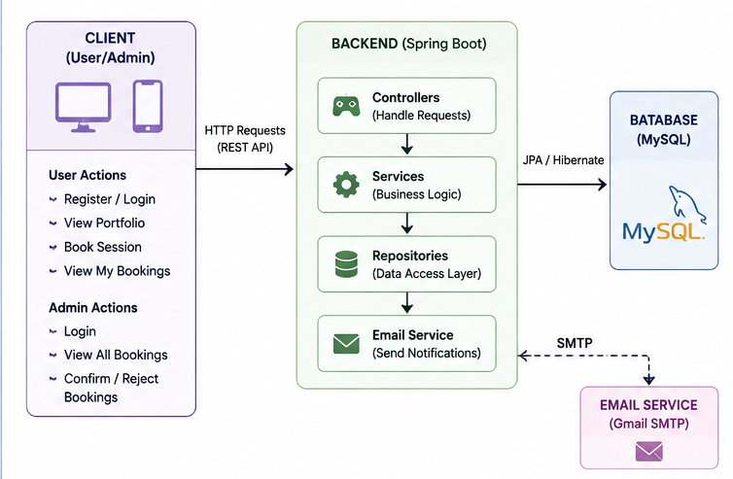

7. DATABASE DESIGN
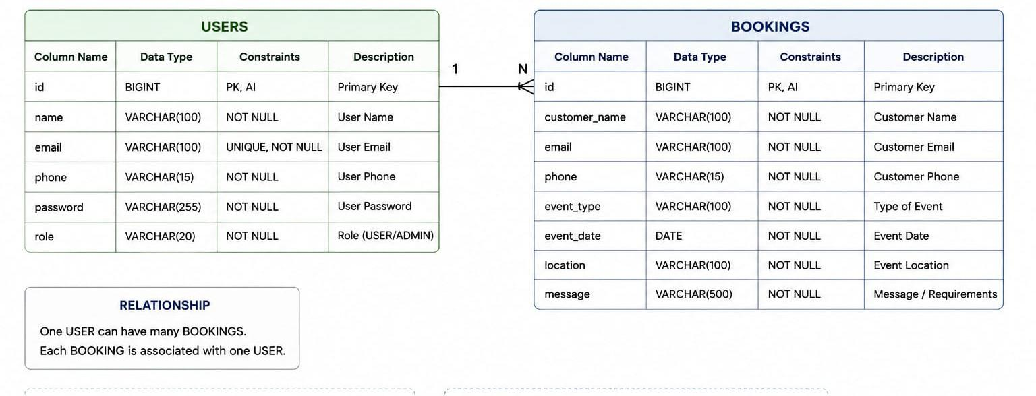

8. APPLICATION WORKFLOW

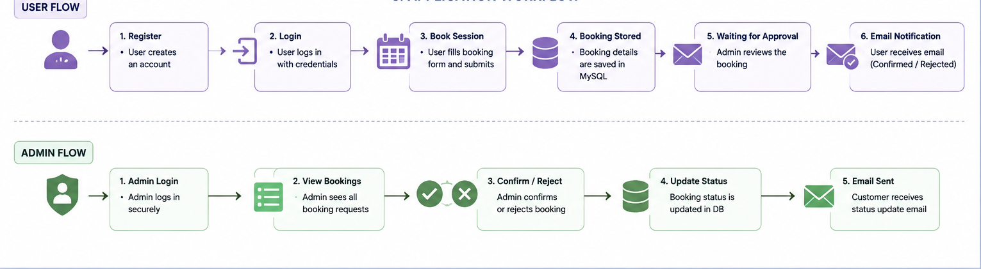

9. API ENDPOINTS

User APIs
Method | Endpoint | Description
POST | /users/register | Register new user
POST | /users/login | User login

Booking APIs
Method | Endpoint | Description
POST | /booking/add | Create booking
GET | /booking/all | Retrieve all bookings
PUT | /booking/confirm/{id} | Confirm booking
PUT | /booking/reject/{id} | Reject booking
GET | /booking/user/{email} | View user bookings

10. SCREENSHOTS
Home Page
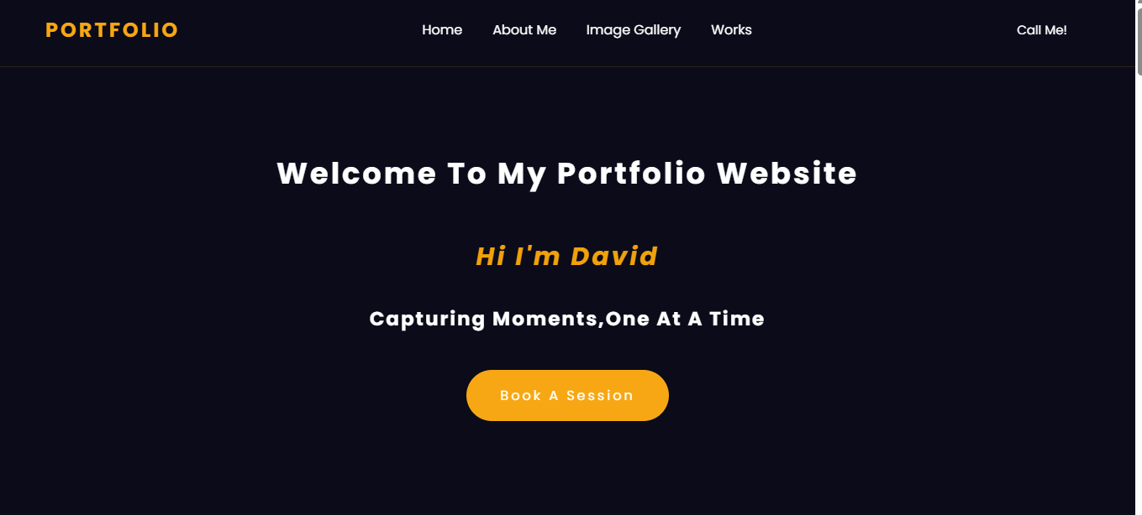
About Section

Portfolio Gallery
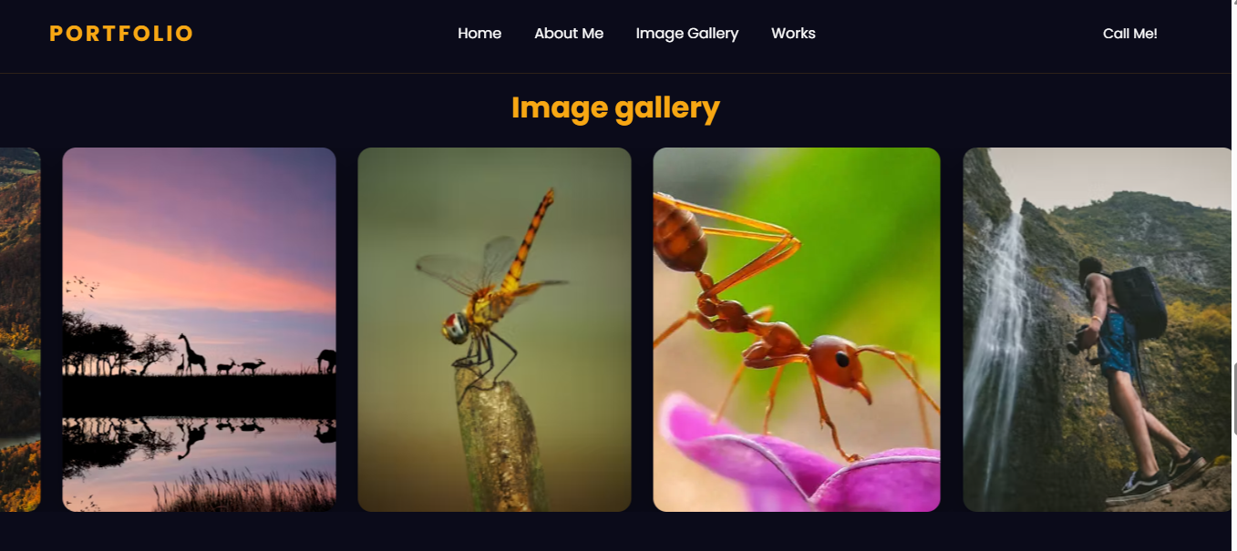
Login Page
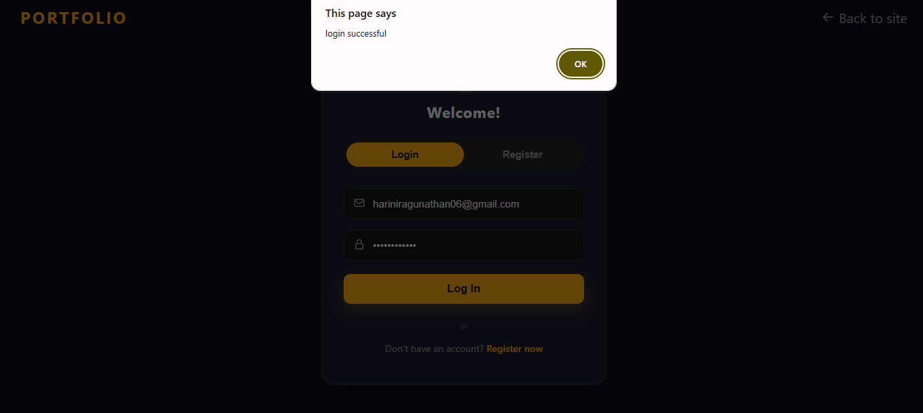

Booking Page
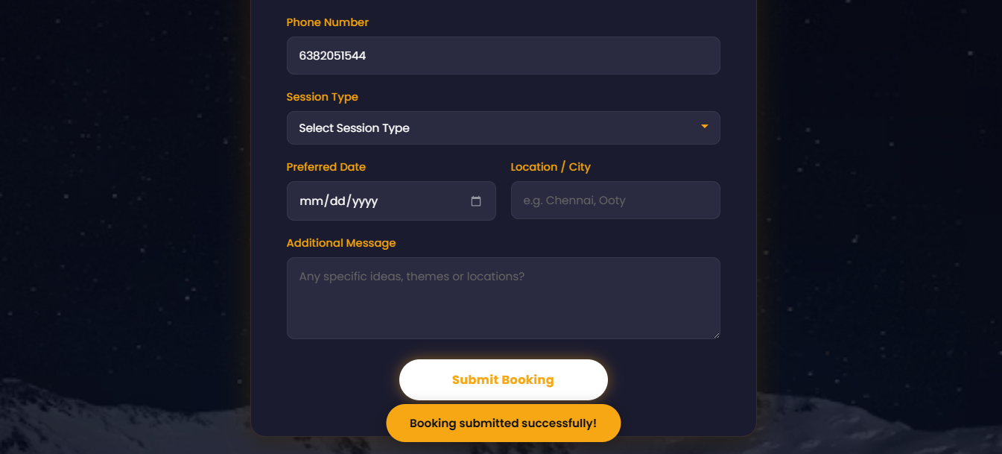
My Bookings Page
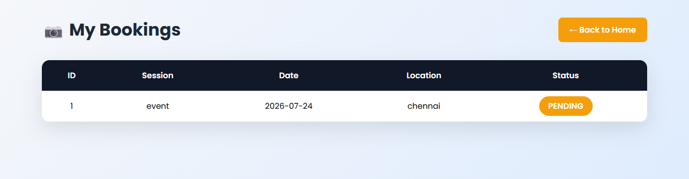
Admin Dashboard
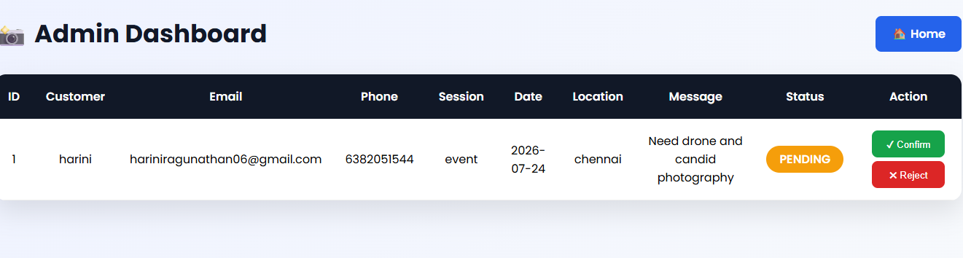
Booking Confirmation
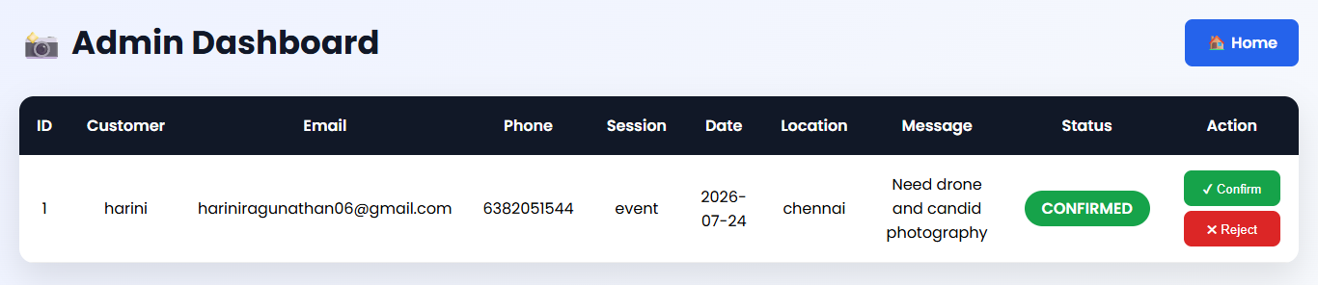

Email Notification
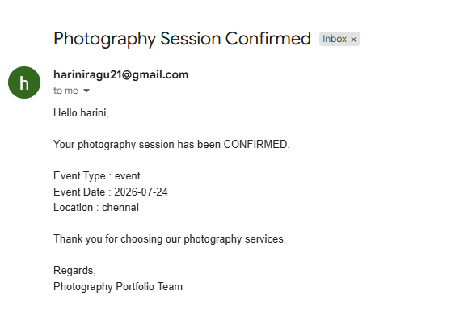
MySQL Database Tables
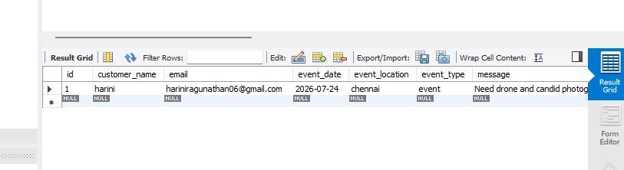

11. CHALLENGES FACED
During development, several technical challenges were encountered:
- Implementing role-based authentication for users and administrators.
- Integrating frontend pages with Spring Boot REST APIs.
- Configuring Spring Mail to send email notifications.
- Managing booking status updates.
- Designing a responsive user interface.

12. FUTURE ENHANCEMENTS
The following features can be added in future versions:
- Online payment integration
- Gallery management with image upload
- Booking search and filter
- Booking analytics dashboard
- Customer review and rating system
- Multiple photographer management
- Calendar-based scheduling
- SMS notifications
- Password reset functionality
- JWT-based authentication and authorization

13. CONCLUSION
The Photographer Portfolio Website successfully demonstrates the implementation of a full-stack web application using HTML, CSS, JavaScript, Spring Boot, and MySQL.
The application provides a streamlined booking process for customers while enabling administrators to manage bookings efficiently through a dedicated dashboard. Email notifications enhance communication by keeping customers informed about their booking status.
This project strengthened practical knowledge of frontend development, backend REST API development, database integration, authentication, email services, and responsive web design. It also reflects the ability to build and deploy a complete web application using industry-relevant technologies.

